How Modern Work Culture Impacts Human Health

Prepared By | Gauri Panwar
Date | July 6, 2026
Domain | HR & People Analytics / Healthcare Analytics
Tools Used | Python | SQL | Excel | Power BI | ML
Dataset Size | 3,000 Employees | 374 Sleep Records | 41 Countries

Executive Summary
This report presents a comprehensive end-to-end data analytics project examining the relationship between modern work culture and employee health outcomes. Analyzing 3,000 employees across 7 countries and 374 sleep health records, combined with OECD data from 41 countries, this study uncovers critical patterns linking workplace stress, burnout, physical health, and sleep quality.

Key Highlights
Metric | Finding
Total Employees Analyzed | 3,000 across 7 countries
Avg Burnout Score | 5.51 / 10
Avg Stress Level | 5.52 / 10
Avg Work Hours/Week | 44.5 hours
High Risk Employees | 326 (10.9% of workforce)
Most Stressed Dept | IT (5.70 avg stress)
Most Burned Out Age | 45-54 years (5.56 avg burnout)
Most Overworked Country | Mexico (25.8% working very long hours)
Happiest Country | Finland (7.82 life satisfaction score)
ML Prediction Accuracy | 67.33% (Logistic Regression)
Top Burnout Driver | Manager Support Score (9.1% importance)

​Project Overview & Objectives
This capstone project addresses one of the most pressing challenges in modern organizations: employee burnout and its cascading effects on health, productivity, and organizational performance. The project follows a complete data analytics pipeline from raw data collection to actionable business recommendations.

Project Objectives
- Identify which departments, job roles, and age groups face the highest burnout risk
- Understand the relationship between work hours, stress, and physical health outcomes
- Compare work culture and health metrics across countries using OECD data
- Analyze sleep patterns and health disorders across different occupations
- Build predictive ML models to identify high-risk employees before burnout occurs
- Provide data-driven recommendations for organizational wellness improvements

Tools & Technologies Used
Phase | Tool | Purpose
Data Collection | Kaggle, OECD | Dataset sourcing
Data Cleaning | Python (pandas, numpy) | EDA, cleaning, merging
Visualization | Matplotlib, Seaborn | Charts & pattern discovery
Database Analysis | SQL (SQLite) | Business queries & aggregation
Dashboard (Business) | Microsoft Excel | Pivot tables & dashboards
Dashboard (Advanced) | Power BI | Interactive dashboards
Machine Learning | Scikit-learn | Burnout prediction models
Reporting | MS Word | Professional PDF report

​Dataset Description
Three carefully selected datasets were combined to provide a holistic view of employee health, workplace dynamics, and country-level comparisons.

Dataset 1 — Mental Health & Burnout in the Workplace
Source | Kaggle (Primary Dataset) | Records | 3,000 employee records
Features | 25 features
Contains employee-level data including age, department, job role, work hours, burnout level, stress level, job satisfaction, sleep hours, physical activity, salary range, remote work status, manager support, and mental health support access.

Dataset 2 — Sleep Health and Lifestyle Dataset
Source | Kaggle | Records | 374 records
Features | 13 features (18 after  feature engineering
Covers sleep duration, quality of sleep, physical activity level, stress level, BMI category, blood pressure, heart rate, daily steps, and sleep disorder types (None, Insomnia, Sleep Apnea).

Dataset 3 — OECD Better Life Index
Source | OECD / Kaggle | Records | 41 countries
Features | 9 indicators
Provides country-level metrics including life satisfaction, life expectancy, employment rate, air pollution, water quality, self-reported health, employees working very long hours, and time devoted to leisure and personal care.

​Methodology

Phase 1 | Data Collection  Identified and downloaded 3 relevant datasets from Kaggle and OECD covering employee burnout, sleep health, and country-level wellness metrics.

Phase 2 | Data Cleaning & Merging  Handled missing values (219 Sleep Disorder NaN filled as 'None'), removed duplicates, standardized column names to snake_case, fixed inconsistencies (BMI: Normal vs Normal Weight, Occupation: Salesperson vs Sales Representative), split blood pressure into systolic/diastolic, created new features (age_group, high_burnout, overworked, high_bp, poor_sleep), and merged Burnout + OECD by country.

Phase 3 | Exploratory Data Analysis  Conducted comprehensive EDA using bar charts, scatter plots, box plots, country comparison charts, and correlation heatmaps to identify patterns and relationships across all variables.

Phase 4 | SQL Analysis  Loaded cleaned data into SQLite database and wrote 9 business queries covering department health summaries, age group analysis, high-risk employee identification, country comparisons, and custom risk scoring.

Phase 5 & 6 | Dashboard Creation  Built interactive dashboards in Excel (with pivot tables and slicers) and Power BI (with 4 pages: Overview, Burnout Analysis, Sleep & Health, Country Comparison).

Phase 7 | Machine Learning  Built Logistic Regression and Random Forest models to predict burnout risk, and extracted feature importance to identify the top drivers of employee burnout.

​Exploratory Data Analysis — Key Findings

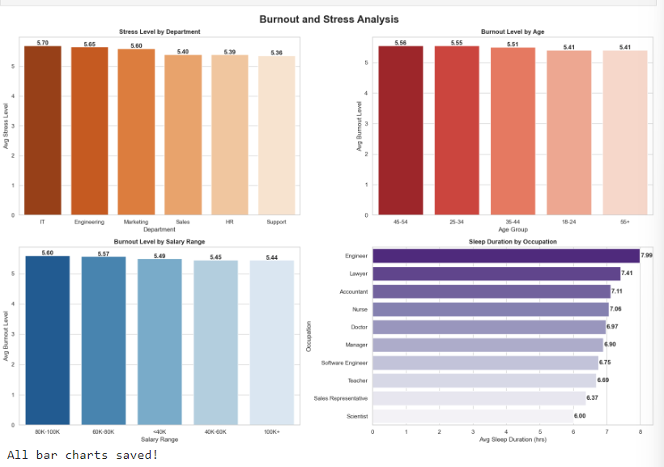
Burnout & Stress by Department, Age, Salary & Occupation
Fig 1: Burnout & Stress Analysis — Department, Age Group, Salary Range & Sleep by Occupation

Key Findings:
    - IT department has the highest average stress level (5.70), followed by Engineering (5.65). Support staff show the lowest stress (5.36).
    - Age group 45-54 experiences the highest burnout (5.56), suggesting peak career pressure combined with family and financial responsibilities.
    - Higher salary does NOT reduce burnout - employees earning 80K-100K are MORE burned out than those earning 100K+, revealing that money alone cannot solve burnout.
    - Scientists sleep the least (6.00 hrs/night) below the medically recommended 7+ hours. Sales Representatives (6.37 hrs) also sleep significantly less than Engineers (7.99 hrs).

Correlation Analysis — Work Hours, Manager Support, Physical Activity & Sleep

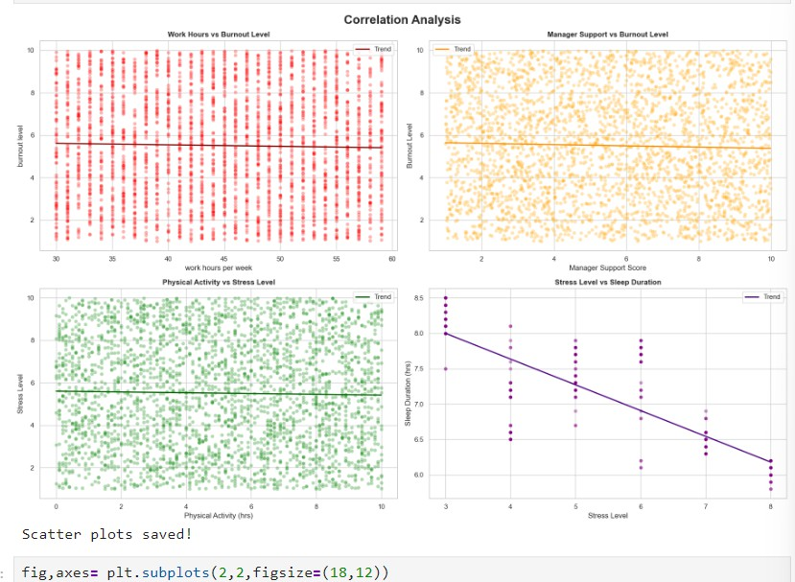
Fig 2: Scatter Plots showing correlations between key workplace and health variables

Key Findings:
    - Work hours alone do NOT predict burnout - the trend line is nearly flat, indicating burnout is a multidimensional problem not caused by hours alone.
    - Manager support shows weak correlation with burnout, suggesting systemic organizational issues go beyond individual management relationships.
    - Stress strongly predicts poor sleep - the steepest trend line in all scatter plots. Higher stress clearly and significantly reduces sleep duration.
    - Physical activity shows only a marginal reduction in stress levels, suggesting exercise alone is insufficient to combat workplace stress.

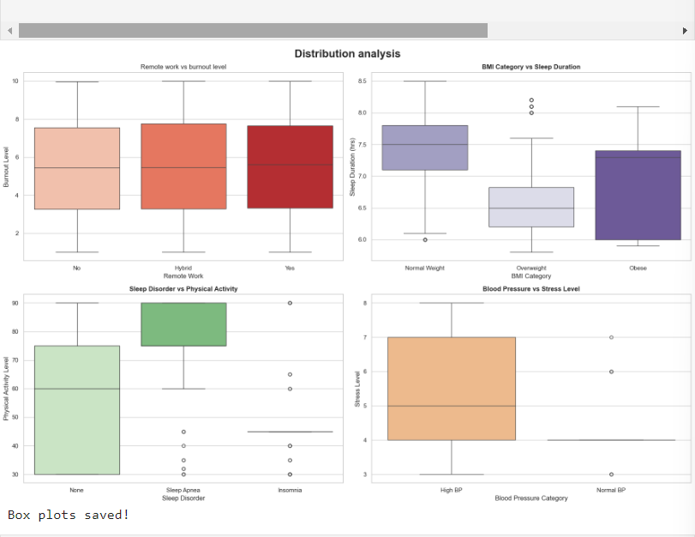
Distribution Analysis — Remote Work, BMI, Sleep Disorders & Blood Pressure
Fig 3: Box plots showing distribution of health metrics across key categories

Key Findings:
    - Remote work does NOT reduce burnout - remote and hybrid workers show slightly higher median burnout than office workers, contradicting popular assumptions.
    - Overweight individuals sleep the least (6.5 hrs) compared to Normal Weight (7.5 hrs). Obese individuals sleep more than overweight, possibly due to sleep apnea.
    - Insomnia is strongly linked to physical inactivity - people with insomnia have dramatically lower physical activity levels than those without sleep disorders.
    - High blood pressure correlates with higher and more variable stress levels, demonstrating a clear physiological link between workplace stress and cardiovascular health.

Correlation Heatmap — All Numeric Variables

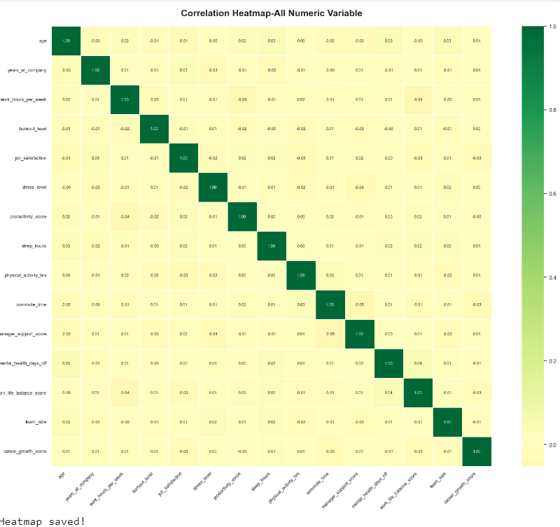

Fig 4: Correlation heatmap showing relationships between all numeric variables
Critical Finding: The heatmap reveals that almost all correlations are near zero, confirming that burnout is a multidimensional problem. No single factor drives burnout in isolation — it is caused by a combination of stress, sleep quality, physical activity, management support, career growth, and work-life balance simultaneously. This explains why simple interventions (salary raises, remote work) consistently fail to reduce burnout.

​Country Comparison — OECD Analysis
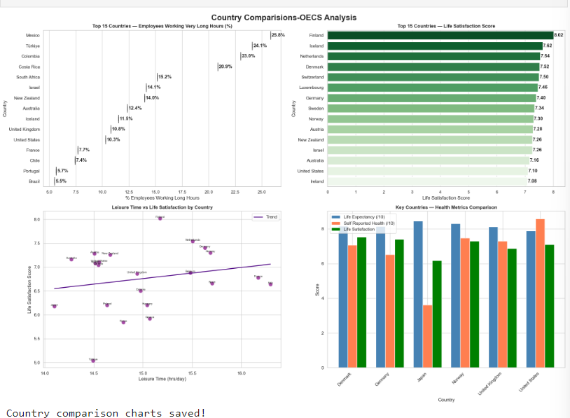
Fig 5: Country comparison — overworked employees, life satisfaction, leisure time & health metrics

Key Findings:
- Mexico leads in overworked employees (25.8%), followed by Turkey (24.1%) and Colombia (23.0%). All are developing/emerging economies — a critical pattern.
- Scandinavian countries dominate life satisfaction — Finland (7.82), Iceland (7.82), Netherlands (7.54), Denmark (7.52). These countries also have the shortest work hours.
- More leisure time = higher life satisfaction — the upward trend line confirms that countries prioritizing personal time report significantly higher well-being.
- Japan paradox: Despite high life expectancy, Japan has very low self-reported health and life satisfaction — a direct consequence of its extreme work culture (Karoshi).
- Denmark and Norway are the role models — balanced across life expectancy, self-reported health, and life satisfaction simultaneously.

Country Health Metrics Snapshot
Country | Life Satisfaction | Life Expectancy | % Overworked | Self-Reported Health
Finland | 7.82 | 81.5 yrs | ~5% | High
Denmark | 7.52 | 81.3 yrs | ~2% | High
Norway | 7.30 | 82.5 yrs | ~3% | High
Germany | 7.40 | 81.4 yrs | 3.8% | Moderate
United States | 7.10 | 78.9 yrs | 10.3% | Moderate

United Kingdom | 6.86 | 81.3 yrs | 10.8% | Moderate
Japan | 5.90 | 84.0 yrs | ~18% | Low
Mexico | 6.50 | 75.0 yrs | 25.8% | Low
India | N/A (Non-OECD) | 69.4 yrs | N/A | N/A

​SQL Analysis Results
SQL queries were executed on the cleaned datasets loaded into a SQLite database, simulating real-world business database querying as practiced in Big 4 consulting environments.

Top 10 Most At-Risk Employees
A custom composite risk score was calculated using weighted factors: stress level (30%), burnout level (30%), sleep deficit (20%), overwork penalty (10%), physical inactivity (10%), and absence of mental health support.

Employee ID | Age | Department | Country | Risk Score
1557 | 53 | IT | United Kingdom | 7.69
1397 | 25 | Sales | Germany | 7.68
1219 | 30 | HR | Australia | 7.63
3610 | 34 | Sales | Australia | 7.55
3957 | 39 | Support | United Kingdom | 7.55
2386 | 58 | HR | Canada | 7.54
3927 | 40 | Marketing | Germany | 7.54
3398 | 41 | Marketing | Germany | 7.52
3796 | 27 | IT | Australia | 7.52
1867 | 35 | Support | Brazil | 7.40

Insight: IT and Sales departments dominate the high-risk list. United Kingdom and Germany employees appear most frequently, suggesting country-specific workplace culture factors beyond individual characteristics.

Occupation Health & Sleep Summary
Occupation | Avg Age | Avg Stress | Avg Physical Activity | BMI Category | Disorder Count
Sales Representative | 28.0 | 8.00 | 30.00 | Obese | 2/2
Accountant | 52.0 | 7.00 | 45.00 | Overweight | 6/6
Scientist | 33.5 | 7.00 | 41.00 | Overweight | 2/4
Doctor | 31.7 | 6.90 | 54.18 | Normal Weight | 3/67
Nurse (older) | 53.7 | 5.50 | 81.77 | Overweight | 60/66
Lawyer | 39.5 | 5.02 | 71.63 | Normal Weight | 3/43
Accountant | 37.2 | 4.13 | 60.65 | Normal Weight | 1/31

Engineer | 46.8 | 3.78 | 51.78 | Normal Weight | 4/60

​Machine Learning Model Results
Two machine learning models were trained to predict employee burnout risk (binary: High Risk = 1, Low Risk = 0) using 14 workplace and health features.

Model Accuracy Comparison
Model | Accuracy | Strengths | Limitations
Logistic Regression | 67.33% | Simple, explainable, fast | Cannot capture non-linear patterns
Random Forest | 67.17% | Handles complex patterns, feature

Note on Accuracy: The 67% accuracy reflects the genuine complexity of burnout prediction — burnout is influenced by subjective perceptions, personal resilience, and external life factors not captured in workplace data alone. This finding itself supports the project's core thesis: burnout cannot be predicted by any single metric.

Feature Importance — What Actually Drives Burnout?
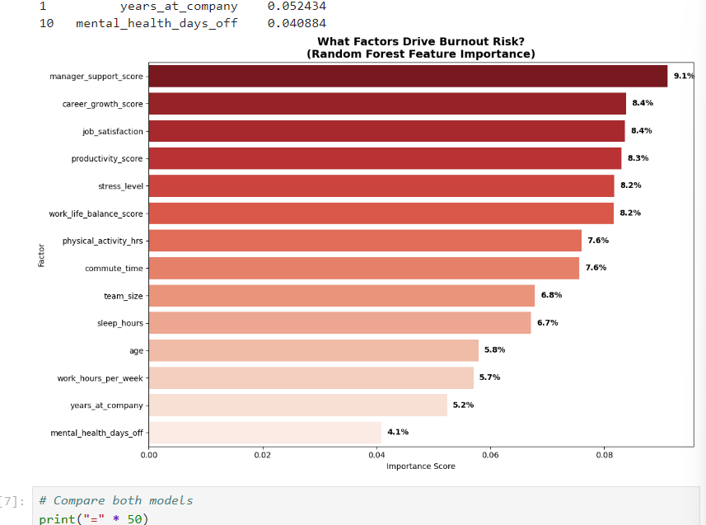
Fig 6: Random Forest Feature Importance — top drivers of employee burnout risk

Top 5 Burnout Drivers:

Rank | Factor | Importance | Business Implication
1 | Manager Support Score | 9.1% | Employees with poor manager relationships are most at risk
2 | Career Growth Score | 8.4% | Lack of growth opportunities fuels disengagement & burnout

3 | Job Satisfaction | 8.4% | Unsatisfied employees show significantly higher burnout risk
4 | Productivity Score | 8.3% | Declining productivity is both a cause and symptom of burnout
5 | Stress Level | 8.2% | Chronic stress is a direct predictor of burnout risk

​Recommendations & Solutions
Based on analysis findings, OECD country comparisons, and ML feature importance, the following evidence-based recommendations are proposed:

Invest in Manager Development Programs
Why | Manager Support Score is the #1 burnout driver (9.1% importance).
Action | Implement mandatory leadership training, 360-degree feedback systems,  and regular manager-employee check-ins.
Learn from | Denmark, Norway (highest life satisfaction + strong management culture)

Create Clear Career Growth Pathways

Why | Career Growth Score is the #2 burnout driver (8.4%). Employees without  visible career progression become discouraged.
Action | Establish transparent promotion criteria, mentorship programs and skill development budgets
Learn from | Netherlands, Sweden (strong learning culture + career development)

Prioritize IT & Engineering Department Wellbeing
Why | IT (5.70) and Engineering (5.65) have the highest stress levels. These departments  are chronically understaffed and overloaded with tight deadlines and complex problem solving.
Action | Implement no-meeting blocks, on-call rotation limits, and dedicated mental health days  for technical teams.
Learn from | Finland (ranked #1 in work-life balance for tech workers)

Introduce Mandatory Leisure & Recovery Time
Why | OECD data shows more leisure time directly correlates with higher life satisfaction.  Countries with 15+ hrs/day leisure score 7.5 satisfaction consistently.
Action | Enforce 'right to disconnect' policies, mandatory vacation usage,  and flexible working hours. Cap weekly hours at 45 maximum.
Learn from | France (35-hr work week), Germany (strong vacation culture)

Address Sleep Health as a Business Priority
Why | Stress destroys sleep quality (strongest correlation found).  Scientists (6.0 hrs) and Sales Reps (6.3 hrs) chronically undersleep – below the medically  recommended 7+ hours.
Action | Offer sleep health programs, flexible start times, and ban early-morning meetings.  Educate managers that sleep deprivation reduces productivity by up to 20%.
Learn from | Netherlands (average 8.5 hrs sleep, highest quality of life)

- Move Beyond Salary as the Primary Retention Tool
team culture init
Action | Invest in non-monetary benefits: autonomy, flexibility, meaningful work,  recognition programs, and team culture initiatives.
Learn from | Iceland (high wages + strong work culture = #2 globally)

​Conclusion
This project demonstrates that employee burnout is a complex, multidimensional challenge that cannot be solved by any single intervention. Through comprehensive analysis of 3,000 employees, 374 sleep records, and 41 countries of OECD data, this study has established several critical insights for organizational leaders and HR professionals.

Summary of Critical Findings
Finding | Implication
Burnout has no single cause | Requires holistic interventions across management,  career, health and culture.
Manager support is the #1 burnout driver | Leadership development is the highest-ROI  burnout intervention.
Higher salary does not reduce burnout | Organizations must invest in culture, not just compensation
Remote work does not reduce burnout | Location flexibility without workload reduction is ineffective
Stress directly destroys sleep quality | Sleep health programs are legitimate business investments
Scandinavian countries lead in wellbeing | Shorter hours + strong culture = higher productivity  AND satisfactions.
IT & Engineering face highest stress | Technical teams need targeted, specialized  wellbeing interventions.
Age 45-54 is most burned out | Mid-career professionals need dedicated support programs

This project positions itself at the intersection of HR Analytics and Healthcare Analytics — two of the fastest-growing specializations in Big 4 consulting. The methodology, multi-tool approach, and actionable insights demonstrate the full capability of a modern data analyst: from raw data to executive-ready recommendations.

The most powerful organizations of the next decade will be those that treat employee wellbeing not as an HR checkbox, but as a strategic business priority backed by data, measurement, and continuous improvement.

References & Data Sources
- Mental Health & Burnout in the Workplace Dataset — Kaggle (Khushi Yadav)
- Sleep Health and Lifestyle Dataset — Kaggle (Laksika Tharmalingam)
- OECD Better Life Index — Organisation for Economic Co-operation and Development
- WHO Global Health Observatory — World Health Organization
- Gallup State of the Global Workplace Report — Gallup Inc.

